The State Pyramid Leadership Team is encouraging all Pyramid Coaches to create a professional profile in Nebraska Early Childhood Record System (NECPRS).

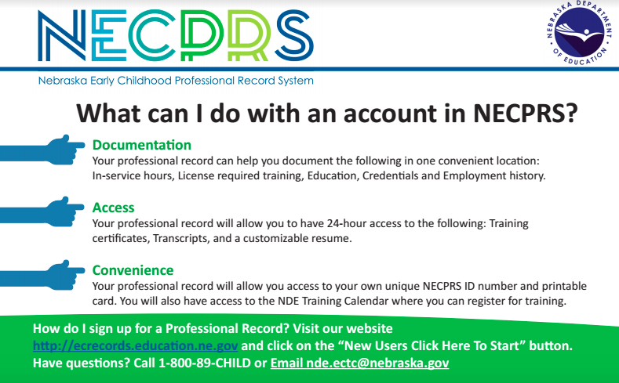
Here is a direct link to the sign-up page http://ecrecords.education.ne.gov/UserProfile.aspx

Instructions on how to create your profile are included in the YouTube videos linked here.

https://www.youtube.com/watch?v=OHpHN-Igbeg

https://www.youtube.com/watch?v=QF9EBJ01o9M

For more detailed instructions go to www.rootedinrelationships.com

If you have any questions about creating your NECPERS account contact Janice Lee at Jlee@nebraskachildre.org

