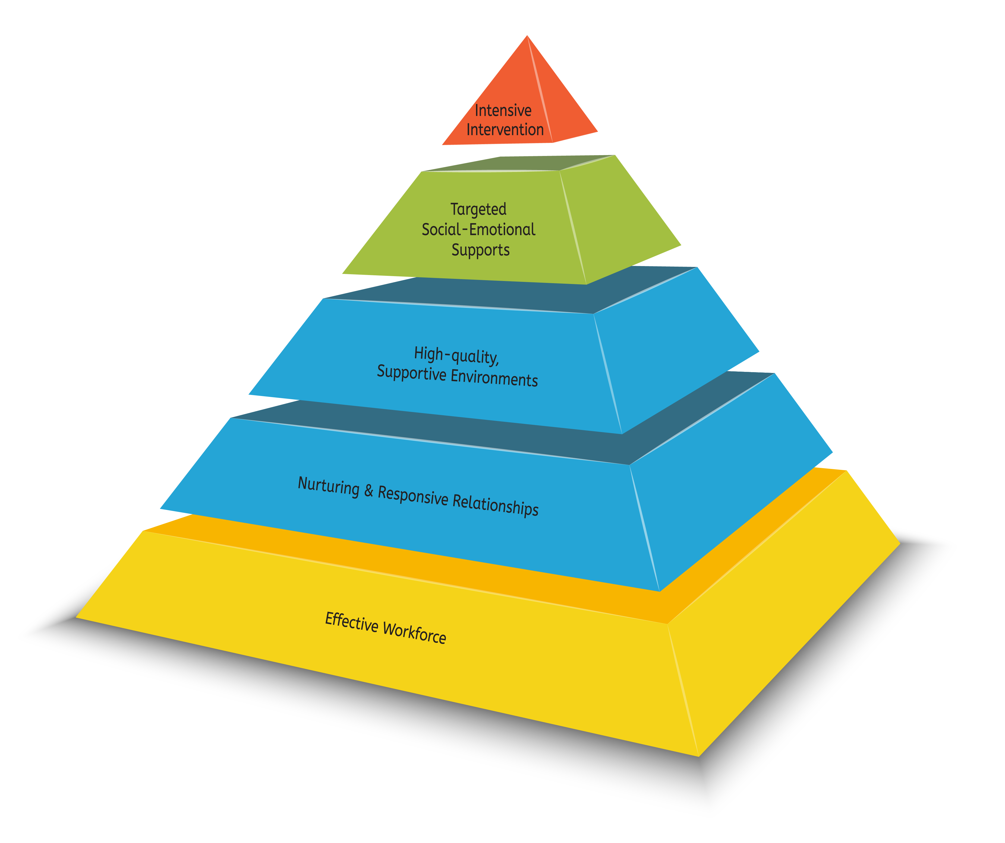

________ County Home & Center
Child Care Providers

Application & Participation Criteria to Participate in Pyramid Model Implementation

Participation Criteria for Pyramid Model Implementation

- Programs must be licensed by DHHS. Preference will be given to programs currently enrolled in Step Up to Quality.

- For Center-Based providers, administrative support to implement the Pyramid Model must be secured.

- Commit to the implementation of the Pyramid Model for 3 years. Implementation includes participation in:

- Year 1
--Trainings: Training will consist of four (4) full-day module trainings (6 hrs. each; 24 total hours of training). Trainings will be on Saturdays from 9-3. In center-based programs the director or a designee must attend the training along with participating providers. The training dates for year 1 are:
- Next date
- Next date
- Next date
- Next date

--Director Training: Directors are required to attend all module trainings along with their center-based providers. In addition, directors will also attend a ½ day training prior to the start of provider training. This training is focused on the role of the director in implementation of the Pyramid Model.

--Coaching: Each selected provider will be assigned a coach. Providers will participate in 2 ½ hours of coaching per month. Coaching will be based on the needs of the provider and at the coach’s discretion.

- Year 2
--Trainings: Trainings will consist of three (3) full-day module trainings (6 hrs. each; 18 total hours of training). Dates TBD.

--Coaching: Coaching needs are expected to decrease to 1 ½ hours of coaching per month. Coaching will be based on the needs of the provider and at the coach’s discretion.

- Year 3
--Trainings: Trainings will consist of two (2) full-day module trainings (6 hrs. each; 12 total hours of training). Dates TBD.

--Coaching: Coaching will be based on the needs of the provider and at the coach’s discretion. Coaching supports will phase out by the end of the third year.

- Participation in Provider Collaboration Meetings—6 meetings each year, designed to build a network of support for the participating providers to ensure sustainability of practices after coaching has ended.

  - Participate in necessary evaluation and data collection processes.

Participating providers should also:

- Consider participation as a member of the (insert planning group name here)

- Be committed to parent education for the families in your program(s)

- Be willing to provide mentoring for those interested in implementing the Pyramid Model in the future.

- Make referrals for children and families when appropriate (Circle of Security Parenting Classes, other parenting supports offered in community, etc.)

- Engage in transition planning for children as appropriate.

Incentives for Participation in Pyramid Model Implementation

--The selected childcare providers and center-based directors will be paid $100 for attending each module training. The trainings listed above will be open to other providers, however only 12 will receive compensation for attending and follow-up coaching.

--The selected providers will be paid $50 per month for coaching in year one and $25 per month for coaching in years two and three.

--A bonus payment of $500 will be paid to each provider at the end of year 3 for successful completion of all module trainings and coaching sessions as well as participating in provider collaboration meetings.

Additional Questions, contact

Application for Pyramid Training/Coaching

Name:

Name of Program:

Program Address:

Phone: |  |  | Fax:
Email: |  |  | Type of Program: Center-Based Home-Based  (circle one)
Primary Administrator: |  |  | Number of staff (if applicable):
Do you serve children on the child care subsidy? Yes No
Is your program enrolled in Step Up to Quality? Yes No |  |  |  | Step: 1 2 3 4 5
Do you currently have a coach working in your program? Yes No |  |  |  | Name:
Ages of children currently serving: infant toddler preschool school-age
(circle all that apply)
Number of children currently serving:

Do you have any children in your care that require special supports or services? If yes, explain.
Have you had any previous Pyramid Model Training? If yes, explain.
Describe why you would like to have Pyramid Model Training/Coaching.
Please list the current challenging behaviors you are experiencing in your program.
Describe what you are currently doing to support children’s social and emotional development.
What are your strengths?
CENTER BASED PROGRAMS ONLY: Please provide the following for each classroom that will participate in coaching.
Classroom Name | Age of Children | Number of Children |  |  | Name of provider who will receive coaching
Application Submission
By submitting this application you acknowledge that you are willing and able to complete all of the required coaching and training specified on page one of this application.

Applications should be submitted to:

Applications are due by (DATE)

