Are you interested in reducing children’s challenging behaviors?

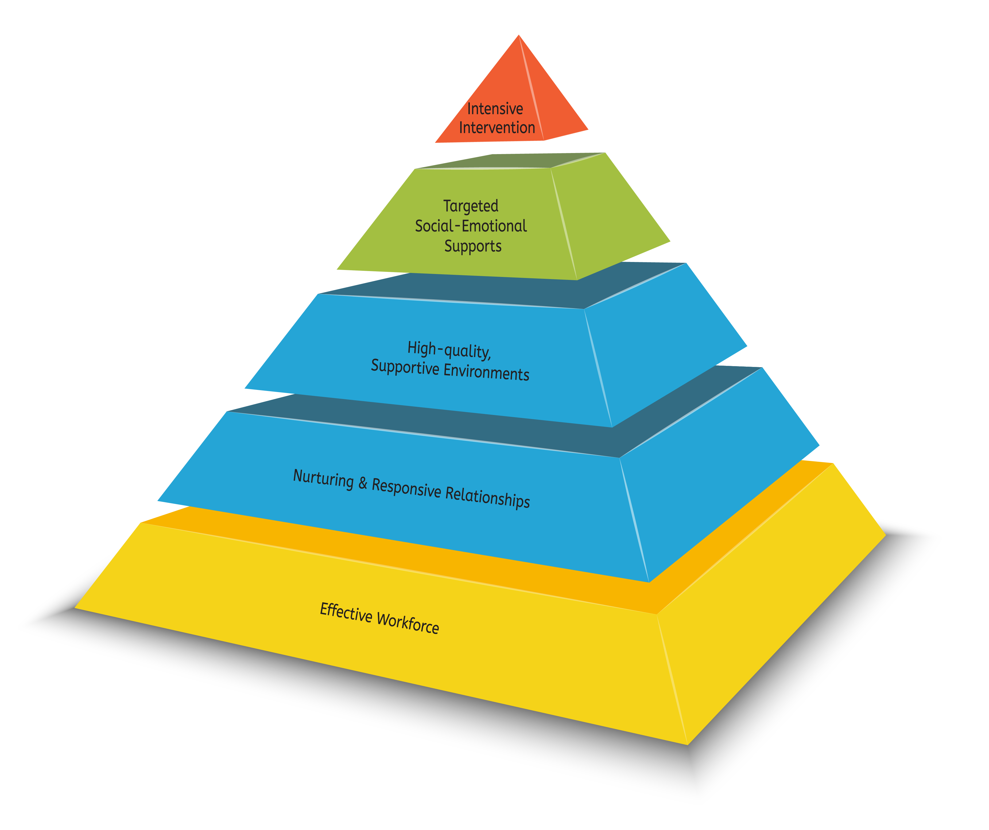
________ County was selected by the Nebraska Children and Families Foundation to work with local partners to develop and implement a long range plan to support the social emotional development of young children (birth-8 years). This initiative is called Rooted in Relationships and is coordinated locally by__________________________.
One part of this initiative is to implement the Pyramid Model, an evidence based framework for improving children’s social emotional development and reducing challenging behavior. Twelve Providers in ______ County will have the opportunity and support needed to implement this model in their programs. Support includes professional development in the form of training and on-site coaching as well as financial support through training and coaching stipends and grants.
Please join us to learn more about this opportunity:
Informational Meeting
DATE
TIME
LOCATION

RSVP to

Questions? Please contact:

