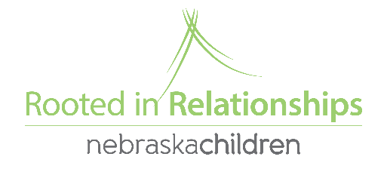
Social Emotional Grant Instructions and Information
Here the steps to complete a SE Grant application
- Go to www.rootedinrelationships.org, select process guide, and then Social Emotional Enhancement Grants.
- Download the application first (you will not be able to save changes until you download the form to your computer and use the downloaded form) and the coach and provider will fill it out together.
- Email it to rootedgrants@nebraskachildren.org (Coach or Provider, please cc one another).
- Watch your email for follow up questions from Sami, or another Rooted staff member.
- Be approved or not approved, you will receive the application back with your approval or denial letter, so you can more clearly see what you asked for and got/didn’t get.
- Turn in your Receipts and Implementation report to Sami Bradley at rootedgrants@nebraskachildren.org
**If you have challenges using the downloadable form please feel free to print it and you can mail it in. Please email rootedgrants@nebraskachilren.org for address if needed.
Here are a few things to know
- Grant approval is not guaranteed, it will depend on availability of funds, the strength of your application (specifically are the items you are requesting necessary to help you meet your one Pyramid coaching goal?), and is at the discretion of Rooted in Relationships staff.
- Social Emotional Enhancement Grants are for child care providers only (both in-home and center-based). If you are a provider in another setting, please work with your coach to determine alternate ways to get the resources that you need.
- Currently we have no limits as to how much or how often you can apply for grants, however you can only have one open grant at a time. Therefore, any grant requests turned in prior to completing an open grant will be denied. If you have had multiple grant requests previously approved, this will be taken into consideration as well.
- Apply for a grant focused on one pyramid related coaching outcome at a time. The best chance for approval is if the items relate directly to helping you meet that goal. The more specific you are, the better.
- Either the coach or the provider can submit the application, please cc the other person when submitting so all are aware.
- We will not approve any electronic devices (ipads, tablets, etc). If you have a specific question about an item, please feel free to email rootedgrants@nebraskachildren.org prior to completing an application if you would like.
- We will not approve large structure outside play equipment. We value outdoor play and know that important social-emotional development happens outside and inside, however our funding would diminish very quickly if we were to make larger playground approvals. Some outdoor equipment may still be approved, feel free to ask for more information.
- It is not uncommon for minor modifications to be asked for, it is a learning process for all!

