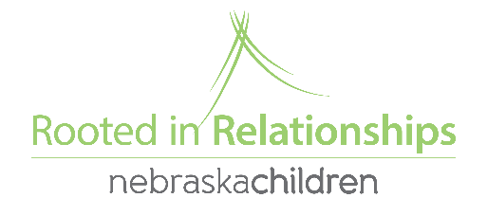
Social Emotional Grant Instructions and Information
Based off of coach and provider feedback we have changed up how Social Emotional Grant applications are completed and turned in. The location of the document and the most of the form information remain the same! Here are the changes.
- The form is now a fillable PDF. Now, you can download the form to your computer and save progress (so it does not need to be completed at one time, and should be more accessible for the coach and provider to work on together)
- Two questions were reworded to be more clear.
- You will attach and email the form to Rootedgrants@nebraskachildren.org (instead of the google doc)
- You will receive the application back with your approval or denial letter, so you can more clearly see what you asked for and got/didn’t get.
Here the steps to complete a SE Grant application
- Go to www.rootedinrelationships.org, then resources, select process guide, and then planning for and implementing the Pyramid model (the application and instructions will be at the very bottom)
- Download first (you will not be able to save changes until you download the form to your computer) the form and the coach and provider will fill it out together.
- Email it to rootedgrants@nebraskachildren.org
- Watch your email for follow up questions from Sami, or another Rooted staff member.
- Be approved or not approved
Here are a few things to know
- Grant approval is not guaranteed, it will depend on availability of funds, the strength of your application (specifically are the items you are requesting necessary to help you meet your Pyramid coaching goal?), and is at the discretion of Rooted in Relationships staff.
- Currently we have no limits as to how much or how often you can apply for grants, however you can only have one open grant at a time. Therefore, any grant requests turned in prior to completing an open grant will be denied.
- We will not approve any electronic device (ipads, tablets, etc). If you have a specific question about an item, please feel free to email rootedgrants@nebraskachildren.org prior to completing an application if you would like.
- We will not approve large structure outside play equipment. We value outdoor play and know that important social-emotional development happens outside and inside, however our funding would diminish very quickly if we were to make larger playground approvals. Some outdoor equipment may still be approved, feel free to ask for more information. Talk with your coach as there are other possible funding sources available that may be able to help with these needs as well!

