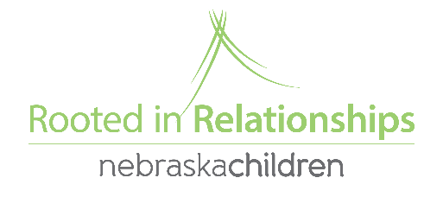

Social Emotional Grant Instructions and Information

**Steps to complete a Social Emotional Grant Application:**

1. Go to [www.rootedinrelationships.org/resources/process-guide/](http://www.rootedinrelationships.org/resources/process-guide/) and click on “Social Emotional Grants”. Here you can find the application, Sample Grants, and Implementation Reports
2. **Download the Grant Application** to complete. This should be completed by the coach and provider together.
3. Email the **completed** application to [rootedgrants@nebraskachildren.org](mailto:rootedgrants@nebraskachildren.org)
4. Watch your email for follow up questions from Christen, or another Rooted staff member.
5. You will receive the application back stating either approval, partial approval, or denial. There will be more information on what was or was not approved and why.
6. The following will need to be sent to [rootedgrants@nebraskachildren.org](mailto:rootedgrants@nebraskachildren.org):
   1. **Receipts** are due **30 days** after applications are approved.
   2. **Implementation reports, pictures, and delivery confirmation** are due **90 days** after applications are approved.

**Additional Information:**

* Grant approval is not guaranteed. Approval will depend on availability of funds, the strength of your application (are the items you are requesting necessary to help you meet your Pyramid coaching goal?) and is at the discretion of Rooted in Relationships staff.
* Social Emotional Enhancement Grants are for child care providers only (both in-home and center-based). If you are a provider in another setting, please work with your coach to determine alternate ways to get the resources that you need.
* Currently we have no limits as to how much or how often you can apply for grants, however you can only have one open grant at a time. Therefore, any grant requests turned in prior to completing an open grant will be denied. If you have had multiple grant requests previously approved, this will be taken into consideration as well.
* We will not approve any electronic devices (iPads, tablets, etc.) If you have a specific question about an item, please feel free to email [rootedgrants@nebraskachildren.org](mailto:rootedgrants@nebraskachildren.org) prior to completing an application.
* Sometimes prices fluctuate between the time the grant application was written and when it was approved. Grant recipients are required to spend the entire amount received, or send the remaining funding back to Nebraska Children. If the provider spends more than the awarded amount, any additional costs are the responsibility of the program to cover.
* Providers in Year 3 are not able to apply after March 1st, as there is limited time for providers to receive and implement coaching around the materials.
* We will not approve large structure outside play equipment. We value outdoor play and know that important social-emotional development happens outside and inside. However, our funding would diminish very quickly if we were to make larger playground approvals. Some outdoor equipment or materials may still be approved. Talk with your coach as there are other possible funding sources available that may be able to help with these needs as well!