Rooted in Relationships Clarifications for Family Child Care Homes (FCCH) Program-Wide PBS Benchmarks of Quality

# Establish and Maintain a Plan for Implementation – items 1-5

1. The provider has purposefully signed up for the program, attended the training and is actively engaged in the coaching. If the provider is resisting the coaching, or is not in full support of the Pyramid Model, this item cannot be marked “in place”.
2. The provider has a written mission or purpose statement that includes Pyramid Model concepts and the provider is able to explain the purpose of the Pyramid Model
3. The *consultant* is the Pyramid Coach.
4. At the start of coaching it is likely that this item will not be in place. For this item to be in place, the provider, with coach support, would utilize the FCCH BOQ and/or The Implementation Guide and a secondary document such as a Coaching Action Plan to set goals for implementing the Pyramid Model. The provider would review the plan, set goals based on the plan, and regularly monitor progress in meeting the goals. The Implementation Guide is something the coach develops with the coachee after they have completed the BOQ. The plan is based on the BOQ data.

# Program-Wide Expectations – items 10-13

Rules are distinct from expectations. Behavioral expectations need to be worded as general statements of positive behavior that are applicable across settings and circumstances. Rules are how those expectations are carried out in specific settings and circumstances. The difference is important because the teaching of expectations is a key element of the Pyramid Model approach.

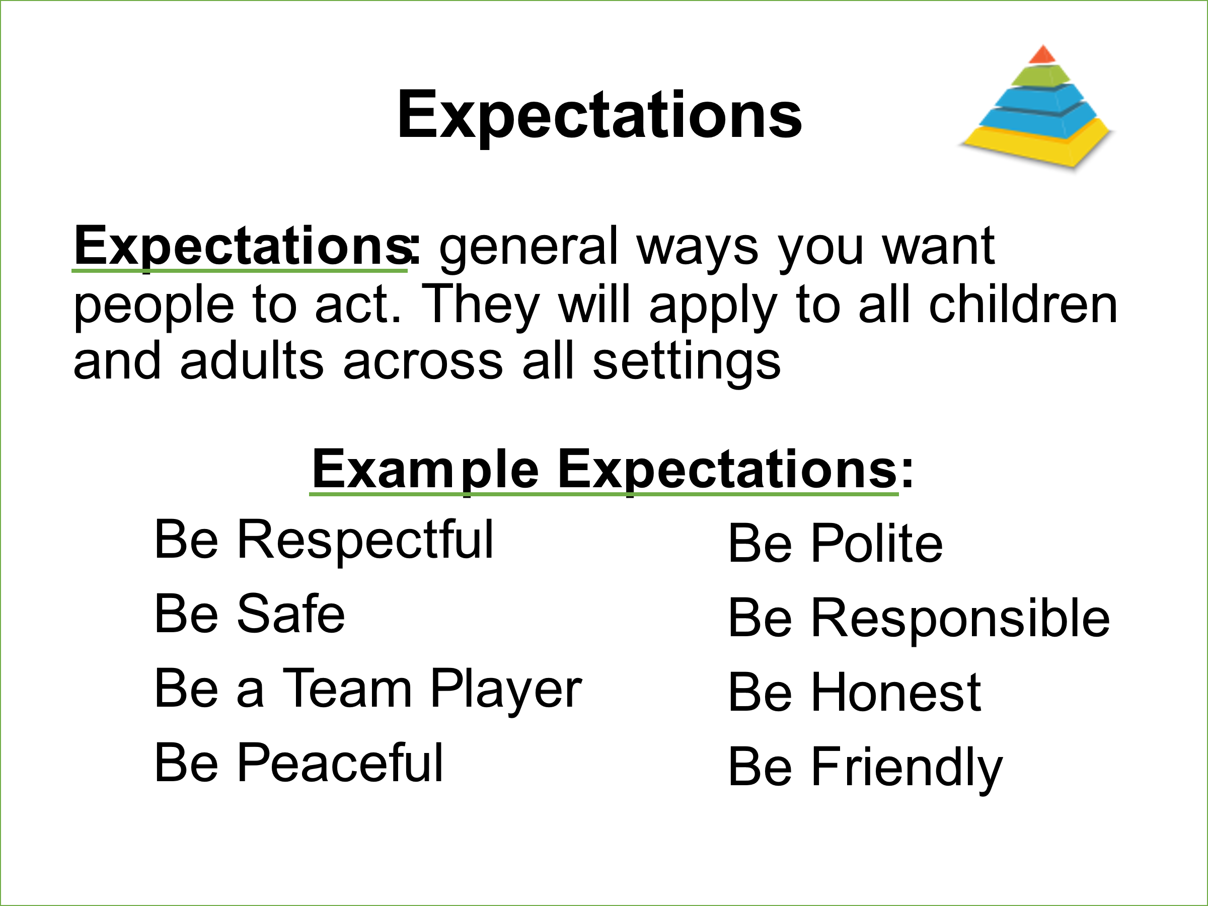

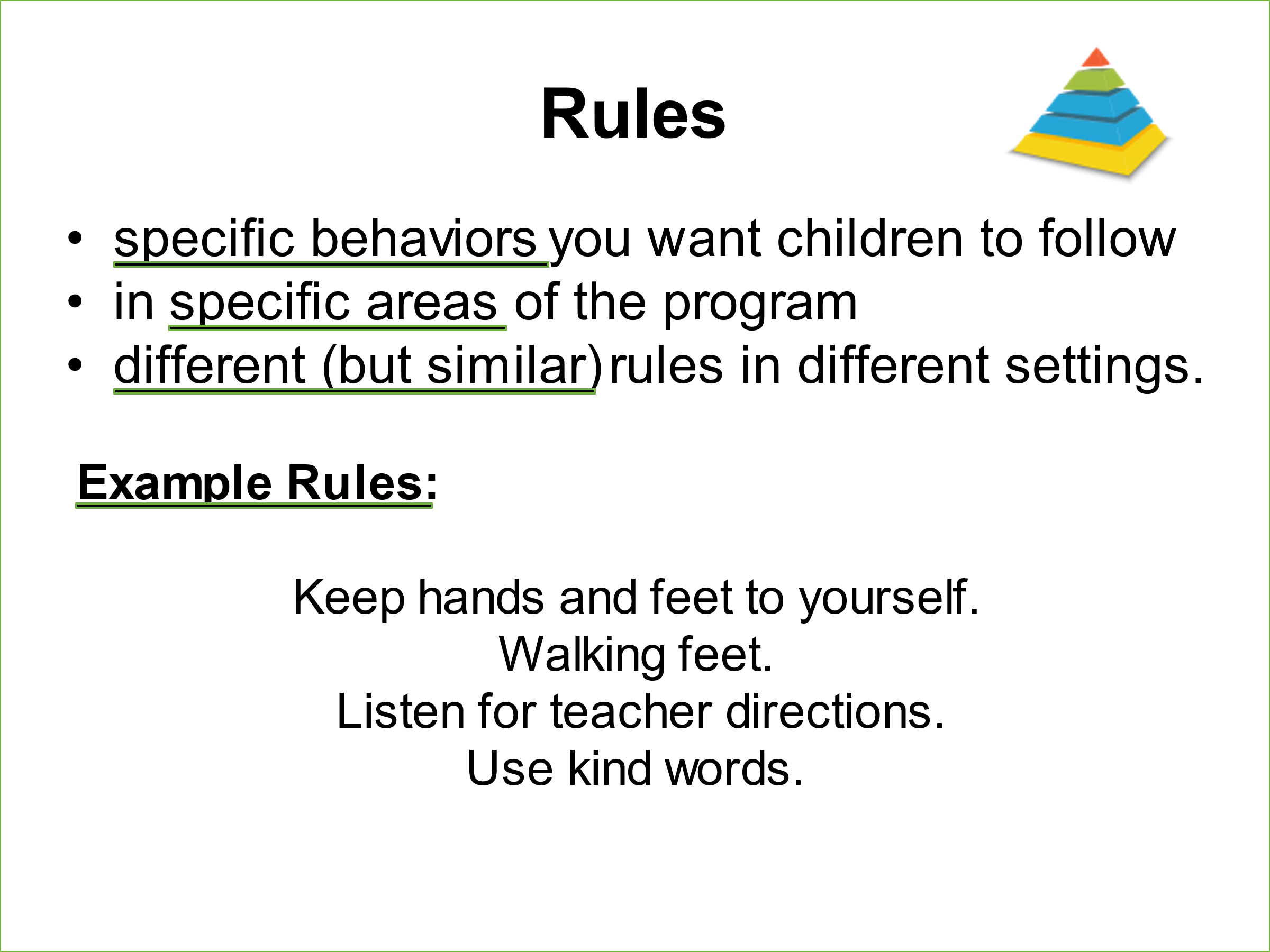

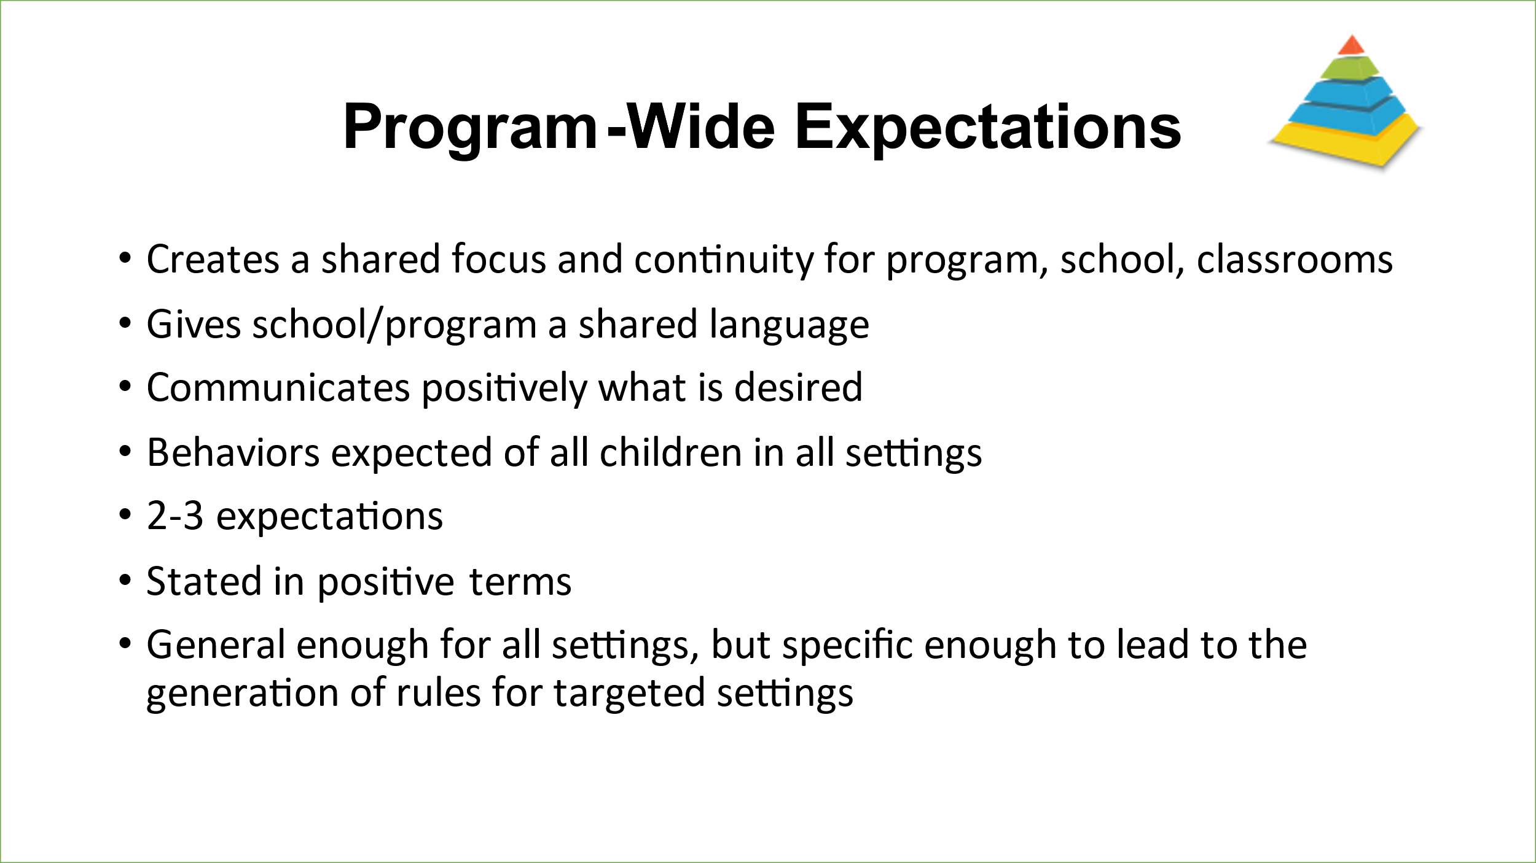

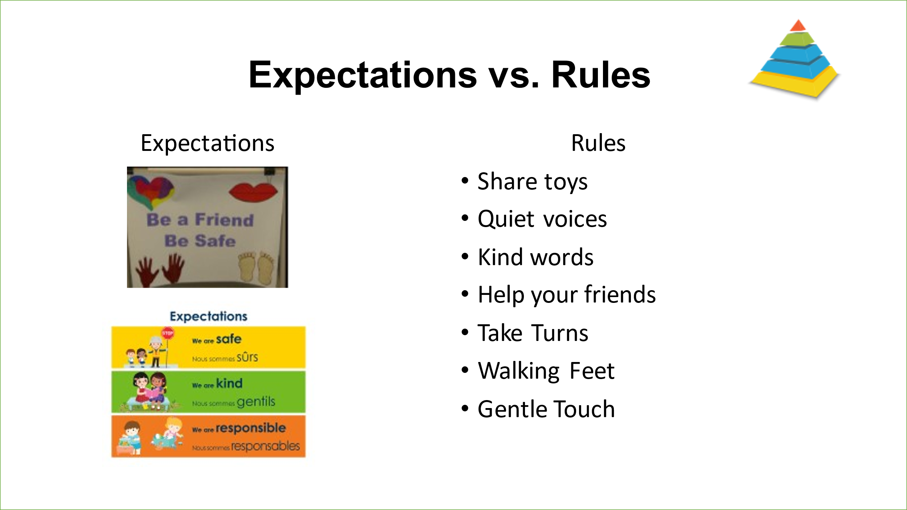

# Implementation of the Pyramid Model is Demonstrated in All Environments – items 17-22

20. Examples of problem behavior include: physical aggression (hitting, kicking, spitting, pinching throwing things, biting), climbing on things that are not designed for climbing, destroying property, taking toys away from other children forcefully, running that poses a safety risk including leaving the property, tantrum behaviors, verbal aggression including yelling, threats, saying bad words, ordering an adult to do something (e.g. “leave me alone!”), persistent crying that is loud, disruptive and/or interferes with a child’s engagement in activities, statements of noncompliance (e.g. “I’m not going to do it!”), inappropriate touching, stripping or other behaviors that are hurtful, disruptive or dangerous to self or others.

22. Provider may not currently have children with challenging behavior in the program. The coach may ask, “Have you ever had children with challenging behavior? How did you handle it?” “Initiating” the plan for a FCC provider may simply be asking for help from a community resource and then being an active participant in the process developed, however that occurs.

# Procedures for Responding to Challenging Behavior – items 23-28

By the time the providers have Tier 3 module training, they should be able to identify persistent challenging behaviors and know about community resources available to assist them in managing these challenging behaviors. The problem-solving process would include the provider knowing the resources, who to go to and how to share these resources with the parent. As previously described, the FCC provider’s role would be active participation in the development of an individualized plan which is likely to be facilitated by a community resource or consultant.

Persistent challenging behavior is differentiated from “problem” behavior described in the previous section and includes: aggression to another child or adult that results in physical pain or harm to that person (includes kicking, hitting, biting, scratching); running out of the home/building, off playground, or from group without responding to the calls of adult, intentionally injuring self in a manner that may cause serious harm (severe head banging, biting self). Persistent challenging behavior could also be defined as problem behavior that continues despite efforts to redirect or use appropriate child guidance. This does not include behaviors that are developmentally expected (e.g. 2 year olds tussling over a toy).

# Professional Development and Staff Support Plan – items 29-36

29, 31, & 34. Automatically in place because they are features of the Rooted in Relationships Project.

32. The needs assessment for this project can be accomplished by using the Participant Implementation Guide.

33. This is developed for each individual provider with support from the coach.

36. The first part might not be applicable to the home based provider because they may be the only staff engaged. If the provider has an assistant, use this item to measure if the provider acknowledges the assistant’s strengths and contributions. For families, does the provider have incentives and strategies to acknowledge them and celebrate them?

# Monitoring Implementation and Outcomes – items 37-42

37. The Benchmarks of Quality Implementation Guide can be used as the primary fidelity measure. It should be completed at the start of coaching, referenced, and reviewed throughout the coaching process and completed a second time at the conclusion of coaching.

38. – 41. Can include the ASQ-SE screener as well as tools and processes for data collection and monitoring that are developed as a result of the coaching process with each individual FCC provider and include positive to negative ratios, short fidelity checklists for a particular practice(s), photos and videos (with provider and family consent), anecdotal notations, etc.