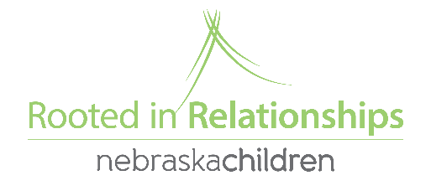
Social Emotional Grant Update

Based off of coach and provider feedback we have changed up how Social Emotional Grant applications are completed and turned in. The location of the document and the most of the form information remain the same! Here are the changes.

- The form is now a fillable PDF. Now, you can download the form to your computer and save progress (so it does not need to be completed at one time, and should be more accessible for the coach and provider to work on together)
- Two questions were reworded to be more clear.
- You will attach and email the form to Rootedgrants@nebraskachildren.org (instead of the google doc)
- You will receive the application back with your approval or denial letter, so you can more clearly see what you asked for and got/didn’t get.

Here the steps to complete a SE Grant application
- Go to www.rootedinrelationships.org, then resources, select process guide, and then planning for and implementing the Pyramid model (the application and instructions will be at the very bottom)
- Download first (you will not be able to save changes until you download the form to your computer) the form and the coach and provider will fill it out together.
- Email it to rootedgrants@nebraskachildren.org
- Watch your email for follow up questions from Sami, or another Rooted staff member.
- Be approved or not approved

